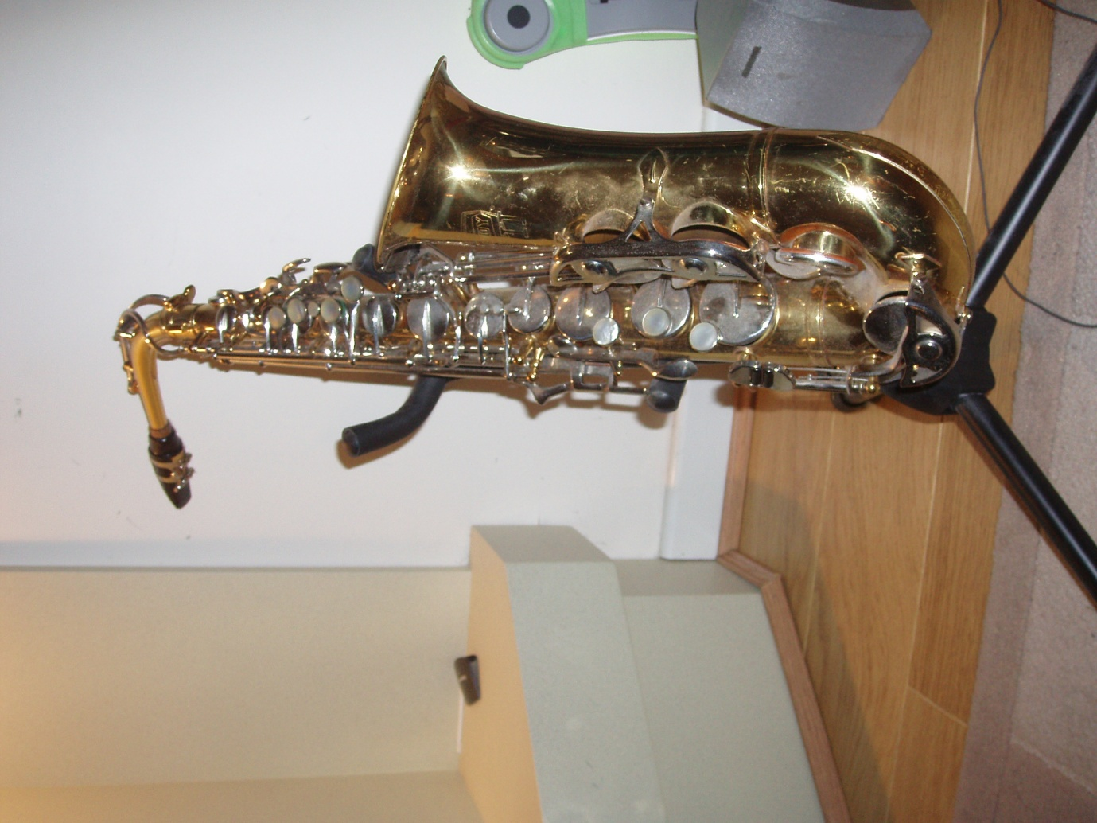
Selmer Bundy Alto Sax
Plus box and stand.
Also fluffy condensation stopper thing (don’t know what it’s called!)
Serial No. 797040, although last two numbers difficult to read.
Totally and professionally reconditioned 2 yrs ago and hardly played since.
Yamaha electric guitar (black) ERG 121
You can contact Ian on 0121-354-5673.
e-mail psychiatrick@googlemail.com

